Pendle Hill Public School

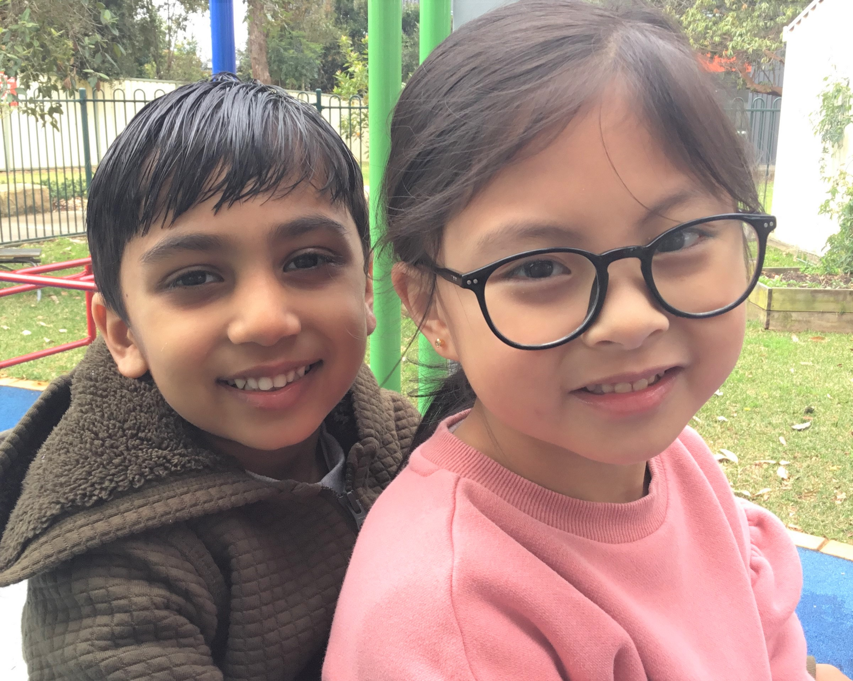

Preschool Information Handbook

**Pendle Hill Public School**

**Address** Pendle Hill Public School

Pendle Way

WENTWORTHVILLE NSW 2145

**Staff** Margaret Akamatis, Teacher

Karen Rowe, School Learning Support Officer

Gabrielle Buczynski, School Principal

**Phone**  9631 8253 or 9631 5857

**Email** [pendlehill-p.school@det.nsw.edu.au](mailto:pendlehill-p.school@det.nsw.edu.au)

**Preschool Hours** 8.55 am -2.55pm Days dependent on the group attended.

The preschool runs during school terms only. Parents will receive a calendar listing session dates for the year.

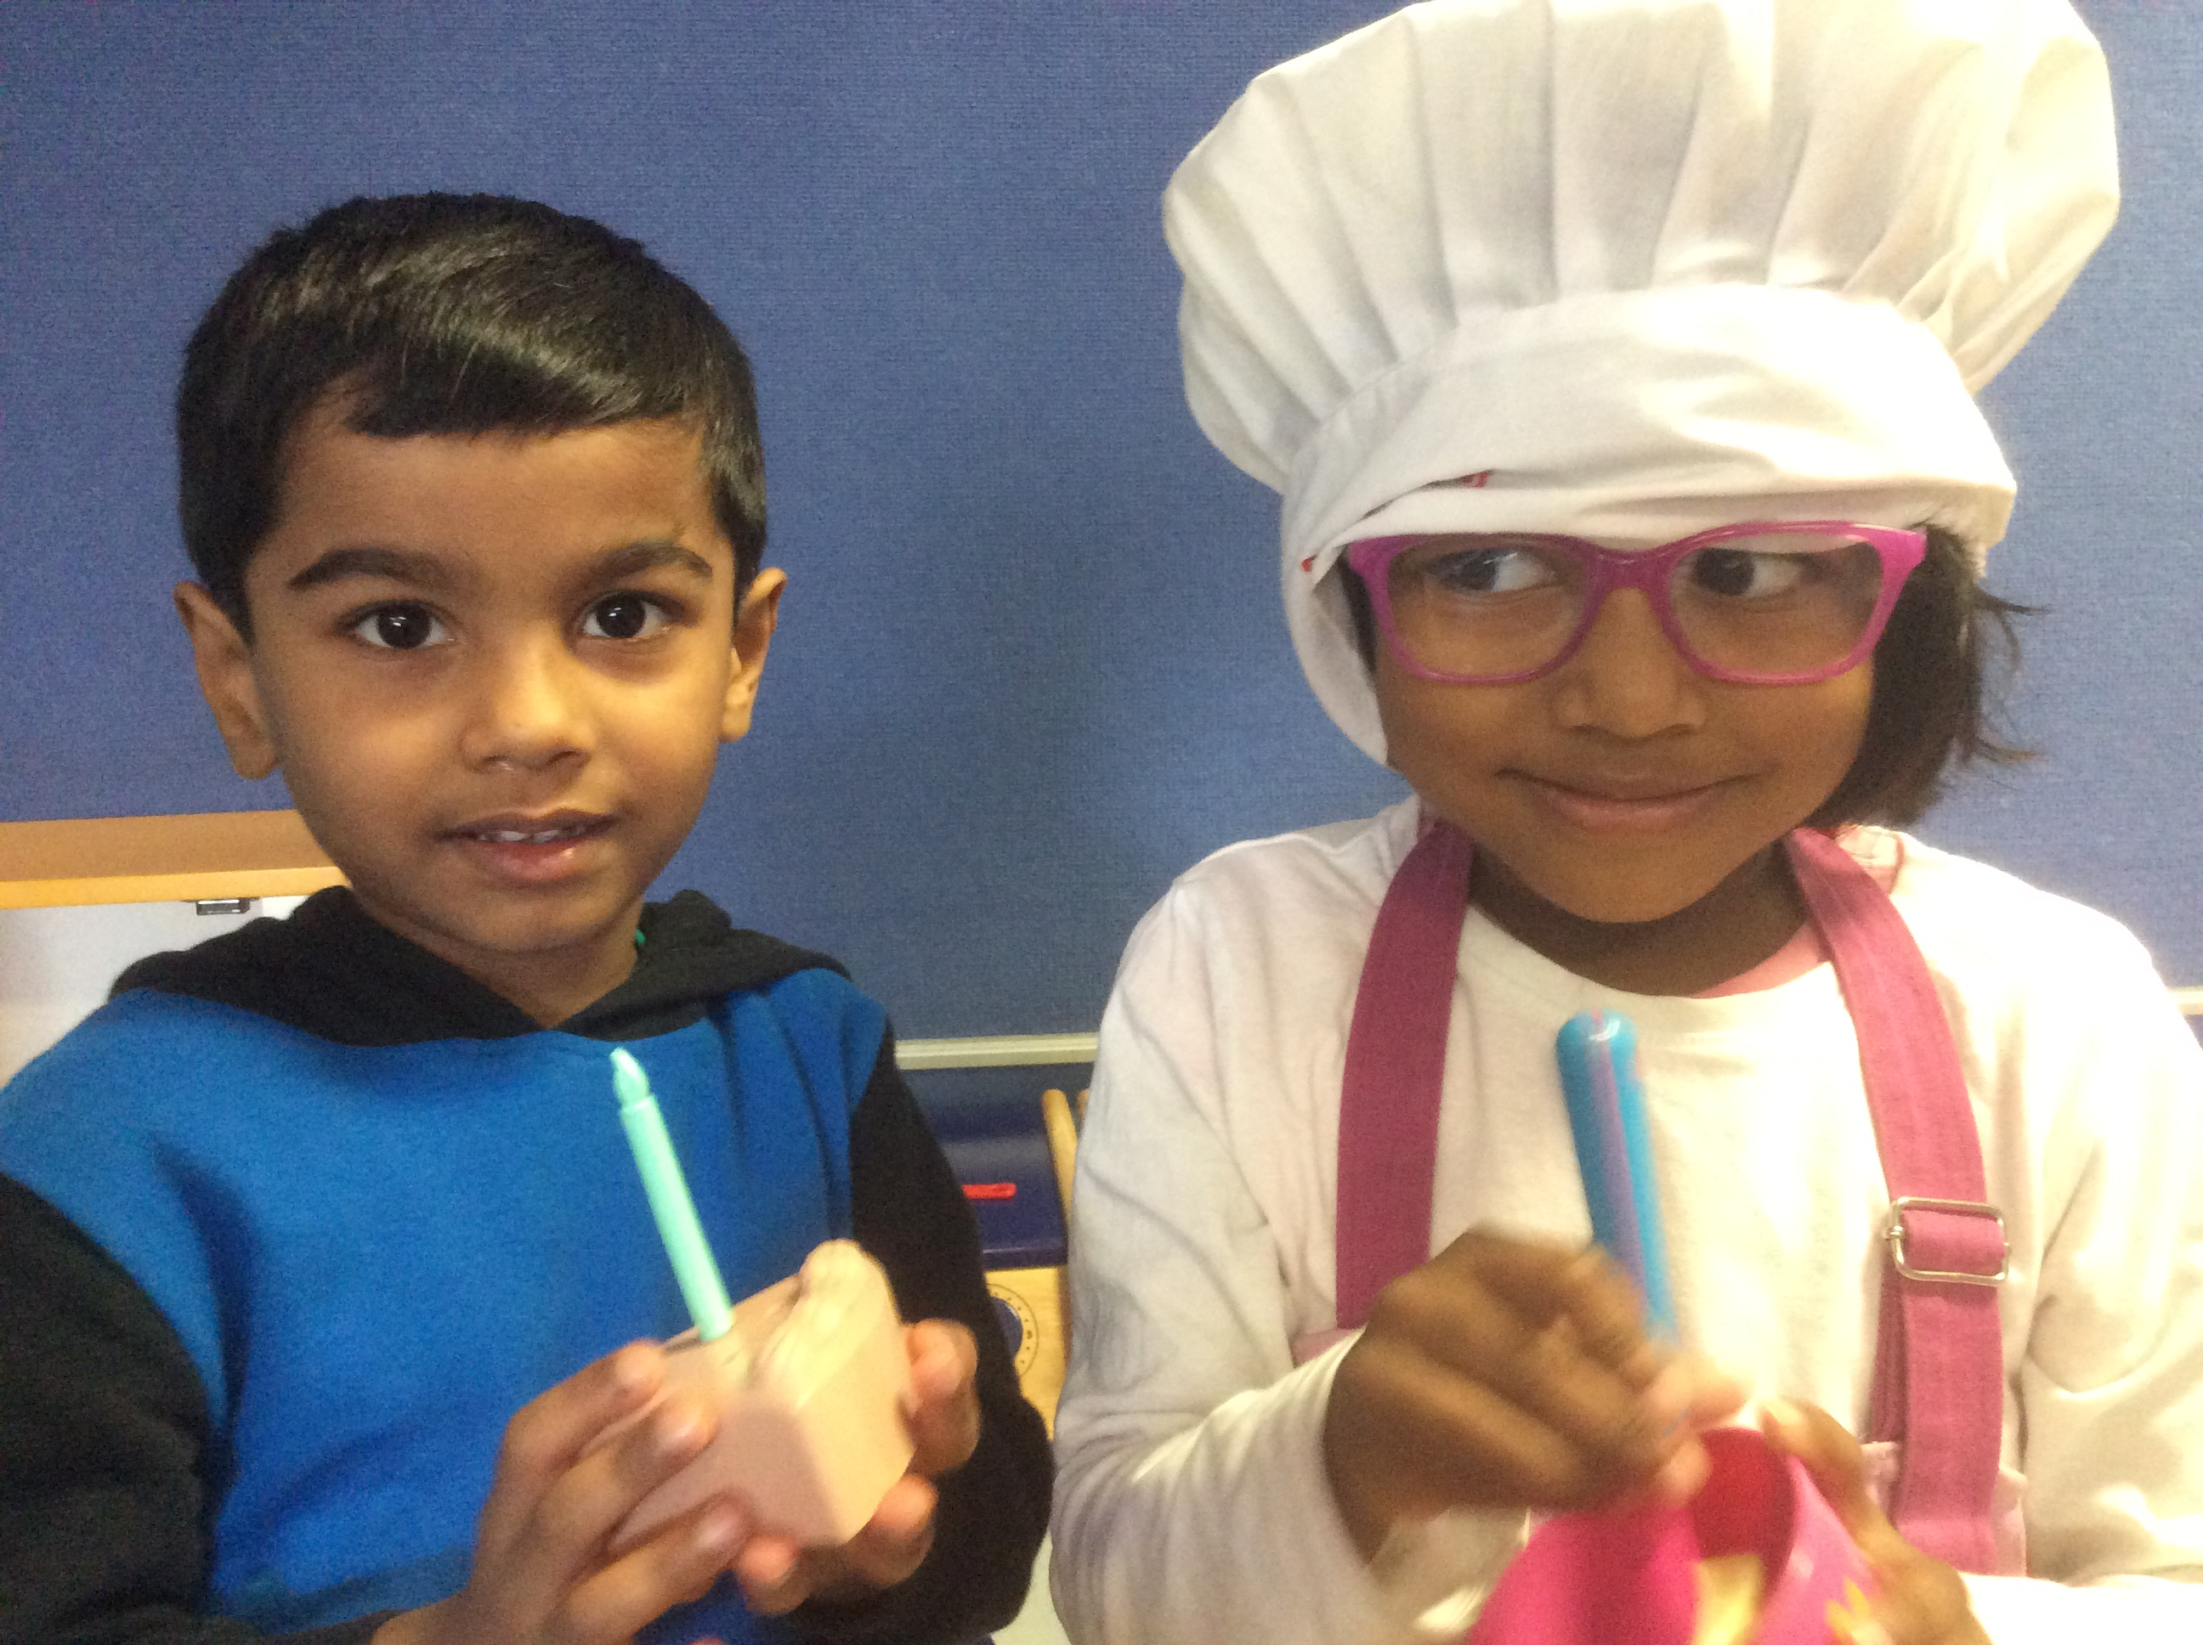

**WELCOME TO OUR PRESCHOOL**

Welcome to Pendle Hill Preschool.

Our preschool is a Department of Education Preschool. Preschools in government schools operated by the Department of Education provide educational programs to children one year before starting school and are an integral part of the school in which they are located. Departmental preschools aim to ensure that “all children experience learning that is engaging and builds success for life” *(Early Years Learning Framework page 7).* Our quality preschool program is informed by the National Quality Framework**. Information on the National quality framework can be found on the Australian Children’s Education and Care Quality Authority (ACECQA) website:**

**http://www.acecqa.gov.au/**

**DoE/School policies and procedures which support and guide our quality program can be accessed on the computer desktop in our preschool, a parent USB and upon request in hard copy. A copy of preschool procedures can be accessed on our website.**

The preschool class is part of Pendle Hill Public School and is staffed with a qualified teacher, who has an early childhood qualification and a school learning support officer who holds a certificate 3 qualification. The teacher and learning support officer work together to implement the preschool program.

This booklet aims to provide a range of information about the preschool to assist children and their families. If you have any questions that are still unanswered, please don’t hesitate to contact the school.

I trust your family’s association with the school is both happy and rewarding. Parents are encouraged to participate in a variety of ways with many formal and informal opportunities for parents to join in activities. We look forward to being part of an enjoyable preschool experience for your child.

Gabrielle Buczynski

Principal

**OUR PHILOSOPHY**

All young children are individuals with their own rich set of experiences, culture and beliefs.

Our community values our nurturing environment and friendly staff, the opportunity for their children to develop social and cognitive skills through play and to be part of a larger school community as they transition to school. They recognise the importance of our strong connections with families and an inclusive, welcoming environment.

Our community values the professionalism of our educators and our commitment to the continual improvement of practice through professional learning and the use of current research to inform practice.

Our children value the friendships they make with others, the positive interactions they have with the educators and the enjoyable experiences they participate in at preschool.

At Pendle Hill Preschool we recognise early childhood as a vital time in each child’s learning and development. We believe children learn best through play based experiences as this provides a context through which they can organise and make sense of their social worlds and express their creativity and uniqueness. Our role is to connect with children and their families and identify their values, interests and experiences in order to plan meaningful authentic learning experiences.

We are committed to providing a child safe environment where the needs, safety and interests of each child guide our planning and decision making. The NSW Child Safe Standards guide our practice in ensuring a child safe environment.

Our expectations for children’s learning are guided by the Early Years Learning Framework which encompasses the principles, practices and outcomes with which to build the curriculum.

We recognise that learning outcomes are most likely to be achieved in a nurturing environment where children feel secure and supported and where educators have formed collaborative partnerships with families and communities.

We place great importance on our learning environment and strive for it to be a welcoming setting which responds **t**o changes and the interests and needs of children and their families. We also recognise the importance of the outdoor learning environment and the rich learning possibilities it has to offer.

We recognise our program plays an important part in children’s transition to school assisting them to explore and make connections with the school environment and community.

Our staff members are committed to ongoing professional learning and critical reflection in order to build their knowledge and keep up with current practices in Early Childhood Education.

**PROGRAM AIMS**

Pendle Hill Public School Preschool runs a preschool program within the guidelines of the NSW Department of Education and The Early Years Learning Framework.

The early years are formative years for all aspects of development – physical, intellectual, social and emotional. The program aims to extend and enrich children’s learning.

Pendle Hill Public School Preschool aims to achieve the following learning outcomes:

* Children have a strong sense of identity
* Children are connected with and contribute to their world
* Children have a strong sense of wellbeing
* Children are confident and involved learners
* Children are effective communicators

**THE PRESCHOOL PROGRAM**

The preschool program is a play based program. Young children learn best through play and activities appropriate to their strengths and interests. Through play experiences children explore the world, learn important concepts and develop skills in many areas. The preschool staff carefully facilitate play based activities to stimulate learning and appeal to children’s interests and needs. The program has a transition to school component in order to foster a smooth transition to Kindergarten. The learning environment is carefully planned to encourage children to explore, solve problems, create and construct.

During the day there will be opportunities for indoor and outdoor play, individual and group activities. Daily activities at preschool may include:

playdough, collage, painting, cutting, games, toys, art/craft, drawing, blocks, puppet theatre, home corner, reading corner, writing corner, literacy activities, book corner, puzzles construction,music, dance, games, dancing, storiespicture talks, name activities, sand and water play, riding bikes, gross motor activities, skipping, bikes, climbing, balance activities, chalk drawing, threading, numeracy activities, environmental activities and outside play

Our program is on display at the sign on book. Parents are welcome to read, comment and provide feedback on programmed activities. Educators plan specific activities for each child to meet the strengths and interests of individual children. Educators use SeeSaw to communicate and share preschool experiences with families on a regular basis. Parents are welcome to comment and provide feedback using the SeeSaw app.

**HELPING YOUR CHILD TO BE READY FOR PRESCHOOL**

Encourage your child to become more independent:

* give your child small tasks and responsibilities at home and praise their success and competence,
* leave your child with a relative or friend for short periods of time so they are used to being away from you,
* talk to your child positively about what they might do at preschool & school,
* encourage your child to put away possessions and play things after use,
* teach your child how to use the toilet independently,
* encourage your child to dress and undress by themselves, and
* teach your child how to take their shoes and socks off and put them on.

Be positive – your attitude will greatly influence your child. Avoid using school as a bribe or a threat.

Preschool should be seen as an exciting place where your child will be able to make new friends, play with exciting new toys, take part in many different activities and have fun!

Feel confident about leaving your child. Always remember to say goodbye and then leave quickly, assuring your child that you will be back to collect him/her.

**SETTLING YOUR CHILD INTO PRESCHOOL**

* Settle your child at an activity and play with him/her for a while. When your child is settled say goodbye and leave quickly, even if they are upset. Remember one of the reasons you are sending your child to preschool is to develop independence,
* Please do not leave without saying goodbye as this is may upset your child. Let your child know you will return in the afternoon to collect them.
* Your child may cling to you and cry as you are leaving. It makes it easier if you reassure your child you will be back soon. Lead them to the teacher or teacher’s assistant and leave quickly. Often, as soon as you have gone, your child will settle down. Remember that if you are anxious about leaving your child you will increase your child’s fears. Try not to show your own anxiety.
* You are most welcome to ring the school if you are concerned about your child after you leave.
* Children adapt more easily when they know that their parents have confidence in the school and in the teachers.
* If your child is reluctant to come to preschool after the initial weeks please discuss this with the staff. It is natural for children to be a bit shy about new situations however some children will take longer to feel confident about coming. The preschool staff will be able to assist if you are concerned about your child settling in.

**General Information**

**ATTENDANCE**

In preparation for school, it is important that your child will arrive on time and will be picked up punctually at the end of the day. Children are expected to attend Preschool regularly. If a child is regularly collected late or does not attend regularly without a good reason, the preschool place may be forfeited and offered to another child on the waiting list.

If your child is absent for more than three days you must notify the office. If you are planning an extended holiday of more than two weeks you must discuss the absence with the school principal. In this case we may not be able to hold your place as we have many children waiting for places and cannot keep places open for extended periods.

**ARRIVAL AND DEPARTURE**

* Children MUST be brought to school and collected by a responsible adult.
* Adults MUST come inside to leave their child and collect their child.
* Upon arrival you must sign your child in and ensure they are in the company of a staff member.
* You must arrive promptly to collect your child.
* When you collect your child you must sign them out and inform a staff member you are collecting them.
* You must nominate on the permission to collect preschool child any adults you will allow to collect your child. No child will be released to any unfamiliar adult without authorisation by the parent. If you have a change to routine and someone not on your list is collecting your child they MUST have a note signed by you explaining this change in routine. You may telephone the school to notify of any last minute changes. Any person who does not regularly collect the child will be required to show identification if they are not known to staff.

**BIRTHDAYS**

As we may have children in the class with allergies and food intolerances, we celebrate birthdays with a wooden cake.

**CLOTHES**

Dress your child in clothes that are easy to manage. Children should be able to play comfortably without about worrying about getting their clothes dirty. The paint used at Preschool is water soluble, so it will wash out with soap and cold water. Sensible shoes should be worn (sneakers with Velcro straps are great). **No thongs or slip on shoes are permitted. Shoes should fit your child’s foot securely.** Every item of clothing should be clearly marked with your child’s name. A spare change of clothes should be placed in a plastic bag in your child’s school bag in case of accidents.



**Examples of good shoes for preschool**

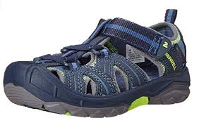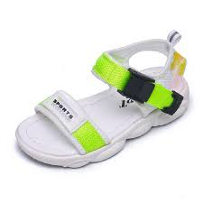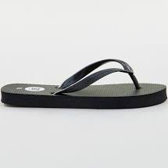

**SUN PROTECTION**

All children are required to wear a hat outdoors. Children should wear clothing which adequately protects them from the sun. Singlet tops and dresses without sleeves are not suitable. We ask that parents supply a bottle of sunscreen 50+ SPF each. Staff apply this to children before going outdoors. We will also be teaching the children how to apply their own sunscreen. If your child requires particular type of sunscreen due to allergies or other issues you will need put this in writing and supply this for your child.



**Examples of sun safe hats for preschool**

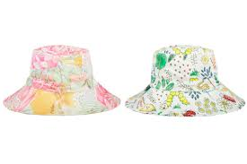

**COMMUNICATION**

It is very important that you read Parent Notice Boards, School Newsletters and SeeSaw app. Each child has a mail pocket which you should check each day. If you have a message for the staff please put it in writing. Verbal messages can be forgotten on a busy day.

The preschool staff welcomes any information you have to share about your child. If you have any particular concerns or worries you are able to make an appointment to discuss these with the preschool teacher.

**CONCERNS AND COMPLAINTS**

If you have a concern about your child, an incident or other issue you may make an appointment to discuss this with the preschool teacher. You may request an interview with the principal should you wish to discuss the issue further or if you have a concern you feel the teacher may not be able to resolve. Issues may also be raised directly with the principal or assistant principals by phoning the office on 96318253. If you are unhappy with the way the school resolves a concern you may discuss the issue with the DoE office at Nirimba ph: 9208 7611.The Early Childhood Education Directorate may also be contacted if you have concerns about our service on 1800 619 113 or by email, ececd@det.nsw.edu.au

**EARLY CHILDHOOD SUPPORT AND PRESCHOOL**

The Preschool and Support Class integrate in a group and on an individual basis.

**FOOD**

Your child will need to bring lunch and fruit break, NO potato chips or lollies, (healthy food only). Please provide food in a lunch box or pack which keeps food cool. If your child has items which require refrigeration you will need to include an ice brick.



Fruit and Dairy break should be:

*fresh fruit, dried fruit, cheese, yoghurt*

*Apples or oranges should be cut into segments and wrapped.*

Drinks should only be:

***WATER***

*We encourage students to bring water as healthy dietary option. The drink should be in a screw or pop top container. The drink needs to last for morning tea and lunch. Additional water is provided in the preschool.*

Lunch could be:

*a sandwich, a wrap, pita or pocket bread, salad*

**Please do not send products that contain peanuts such as peanut butter or nutella.**

**We encourage families to provide food consistent with the Australian Government guidelines, *Get Up and Grow; Healthy Eating and Physical Activity.***

***Brochures available in the preschool***

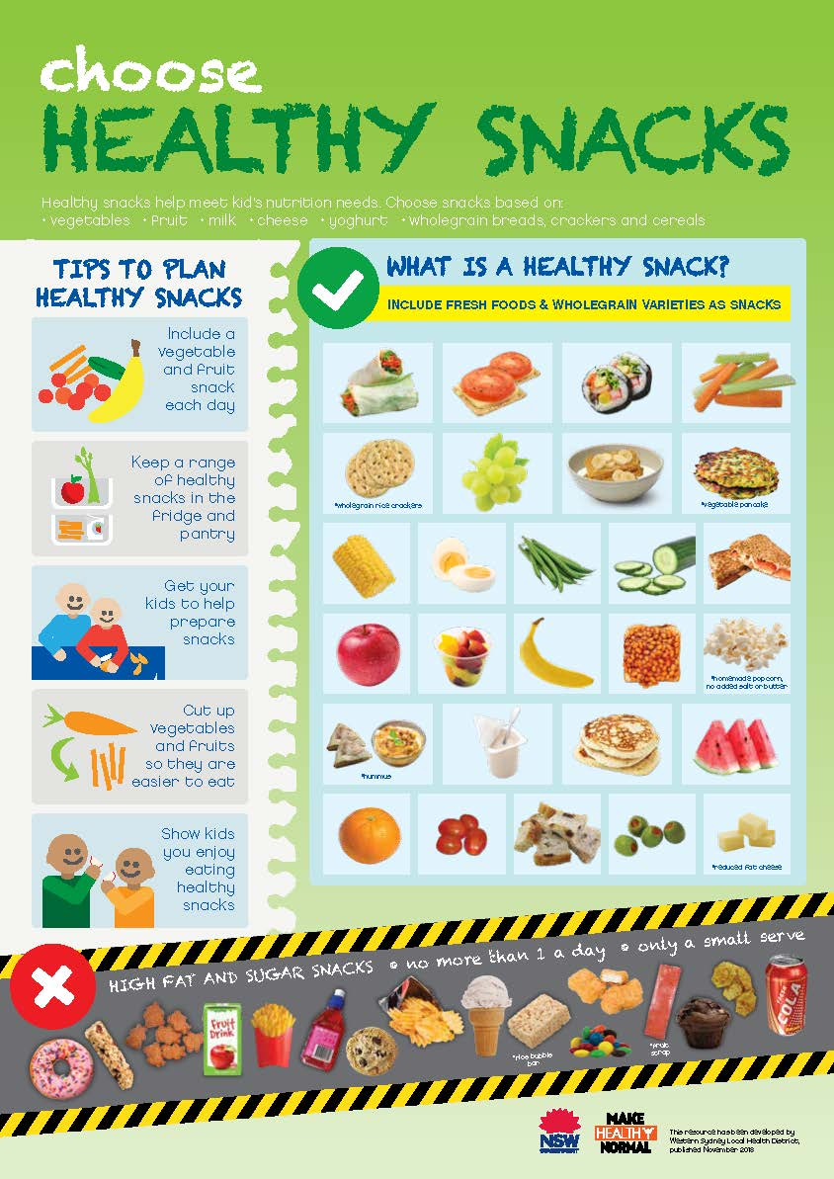

**Examples of ice bricks for preschool**

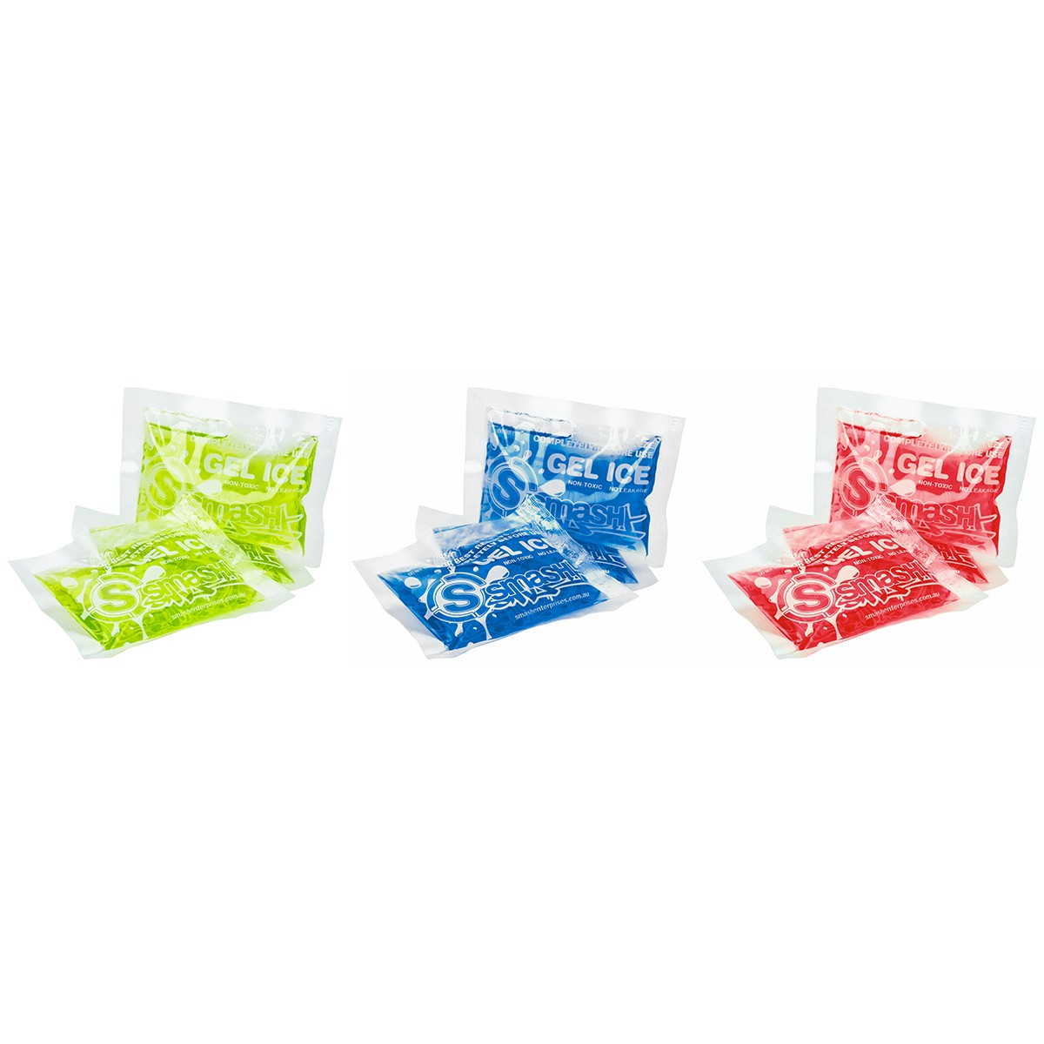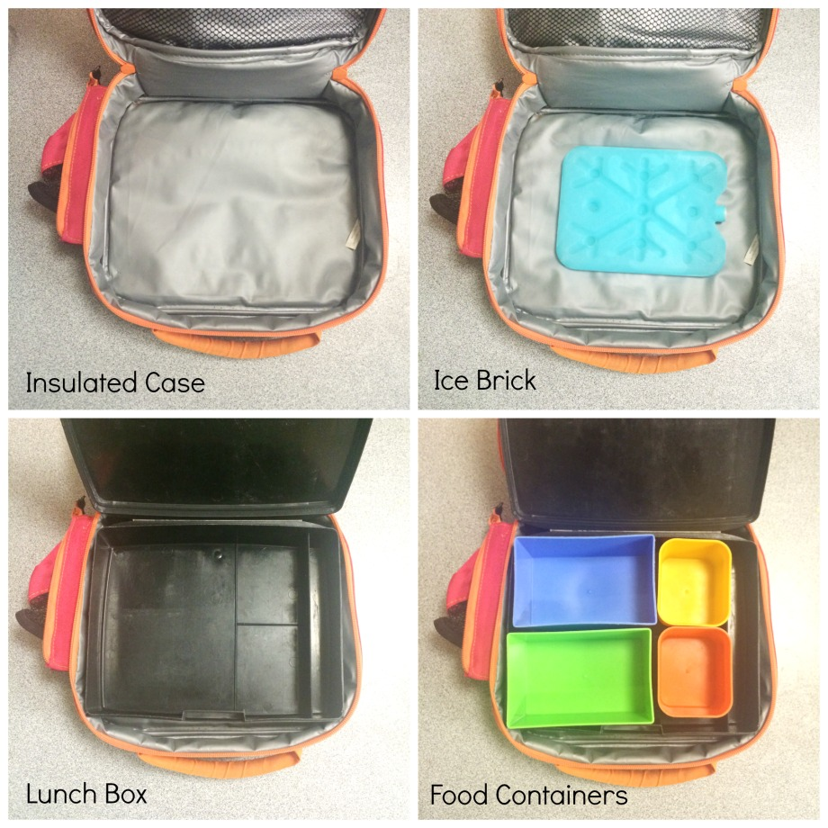

**ILLNESS/ MEDICAL CONDITIONS**

* **If your child has an ongoing medical condition or allergy you must indicate this at enrolment or notify us immediately of any changes or new conditions as soon as you become aware of them.**
* It is mandatory for all children entering preschool to show evidence of Immunisation. A certificate of Immunisation should be obtained from your doctor. If your child receives an immunisation booster during the year, you will need to supply an updated record to the school office.
* Please keep your child home if they are ill. This stops infections spreading to other children and staff.
* Please keep your child at home if they have any COVID symptoms and inform staff if they test positive for COVID.
* If your child is taking any medication at home please notify staff.
* If your child has an accident or becomes ill during the day staff will take care of them. **Please ensure the school always has a current telephone number to contact you in an emergency.**
* If your child has an infectious disease eg: measles, mumps please notify the office. They will require a doctor’s clearance before they return to school.
* If a member of your family has an infectious disease you must notify preschool staff immediately.

**MEDICATION**

Staff can only administer prescription medication unless with doctor’s authorisation for an individual healthcare plan. Children must not keep medication in their bags (including ventolin puffers) parents must hand any medication to staff on arrival. Medication can only be presented in its original packaging and clearly labelled with the child’s name and dosage. A parent must sign a medical authorisation form.

If your child is taking any medication at home please let staff know.

If your child has an ongoing medical condition requiring medication or other assistance at school you will need to discuss this with the school principal.

**PARENTAL INVOLVEMENT**

Parents are a very important part of our Preschool. You can help your child gain the most benefit from Preschool by becoming interested and involved in what they are doing and learning at Preschool. There are many ways you can do this:

* Read the displays/ SeeSaw app. Seesaw highlights events from the day. Displays and pictures describe activities which develop from child initiated experiences, comments or interactions. Through open ended questioning, feedback etc the teacher will use children’s interests and comments to scaffold their learning. Staff will regularly display pictures and work which demonstrate the children’s activities, interests and development.
* Talk to your child about their day. Ask about their friends and what they did or made. If your child tells you about something they have learned try to link the learning to experiences you have had together or something new you will do together. Eg.” I saw the picture you painted of a flower. Did you think we have the same flowers in our garden?” This could lead to a walk in the garden/park/ reading a book and further discussion.
* Parents are welcome to assist during the day at preschool. If you would like to volunteer as a parent helper please see the preschool teacher. Generally we wait until the children are settled late in Term 1 to invite parent helpers into the preschool. Small children or babies are not able to join us.
* If you are a working parent or have a small baby or toddler, the time available for you to join us at Preschool may be limited ask the teacher if there are other ways you can help or join in.
* Read to your child every day. Tell stories in your child’s first language. You can’t start doing this too early.

**REST**

Children are able to rest during the day in quiet areas of the preschool. The preschool provides opportunities for rest time in quiet areas of the room. Facilities are available for children to sleep if they wish. Parents are asked to provide a sheet if the child usually sleeps during the day.

**TISSUES/SOAP**



Please bring two boxes of tissues and two bottles of liquid soap on the first day.

**TOYS**

Please keep toys, lollies and money at home. Toys may get lost or damaged.

**TRAFFIC/CAR PARKS**

Entry to the school and preschool is only permitted through **pedestrian gates. Entry is not permitted through the driveway.** Cars may not bedriven onto school property at all. The car parks are out of bounds to all except staff.

Please park safely & legally in the street being careful not to block neighbours driveways.

**TRANSITION TO SCHOOL**

A transition program operates in Term 3 & Term 4 so that children become familiar with Kindergarten routines.

**What I need for Preschool**

**I need:**



a hat

a bag

a lunch box with an ice brick (that fits inside my bag)



lunch, fruit /dairy break and a bottle of **water**

a drink bottle ( for water)

spare set of clothes and underwear

comfortable play clothes

closed, comfortable shoes

a sheet (only if I need a sleep)

Please label all belongings with your child’s name

**Hearing about your child’s day at preschool**



Seesaw is a digital portfolio that gives you real-time glimpses into your child's preschool day. Seesaw helps you stay in the loop and gives you an opportunity to support your child's learning at home.

**So how does Seesaw work?**

Each child gets their own journal in the Seesaw app and educators will periodically add entries to it, such as photos, videos, drawings or notes. When the journals have been updated with something new, you will receive a notification and can like or comment on the entry.



**Are my child’s work and photos safe?**

In order for Seesaw to be used your child’s name will be entered so their work and photos/video can be tagged to their journal. Student journals are not shared publicly on the internet and can only be accessed by school staff, yourself or anyone you share the login QR code with. Often the photos/video will involve more than one student and so this photo will become a part of multiple children’s journals. This means that the photo/video can be viewed by anyone viewing those other children’s journals. We ask that parents limit any sharing of their login QR code to close family.

Preschool staff will give you instructions about how to access Seesaw at the beginning of the year.